BLOCK of the Month: Let’s go…Fly a KITE!
COLORS: BRIGHTEST BRIGHT KITE with BLACK AND WHITE (B&W) BACKGROUND
CUTTING for 8 ½” x 10 ½” unfinished blocks:
KITE: BRIGHT #1 (1) 5” x 5” (1) 5” x 7” BRIGHT #2 (1) 5” x 5” (1) 5” x 7”
NOTE: Select two different BRIGHTS for your KITE. These directions will make two of the same block.
BACKGROUND: BLACK AND WHITE (2) 5” x 5” (2) 5” x 7”
SEWING: Draw a diagonal line on back of each B&W 5”x7”, as per diagram. NOTE: the lines go in opposite directions on each 5”x7”, this is important! Place one B&W 5” x 7” on top of each BRIGHT 5”x 7”, right sides together, as per diagram. NOTE: this is NOT the same as half square triangles! The rectangles must be askew, as per diagram. Sew ¼” on each side of drawn line, cut on drawn line, press to bright. Trim each of these (4) units to 4 ½” x 6 ½” as per diagram. NOTE: start your measurement from the lower B&W corner of your unit. You trim only two sides of each of these (4) units. The BRIGHT triangle in each of these units will not meet either corner of the unit. The upper corner will be about 1/8” away from the edge and the lower corner will be about ¼” away from the edge, this is correct.
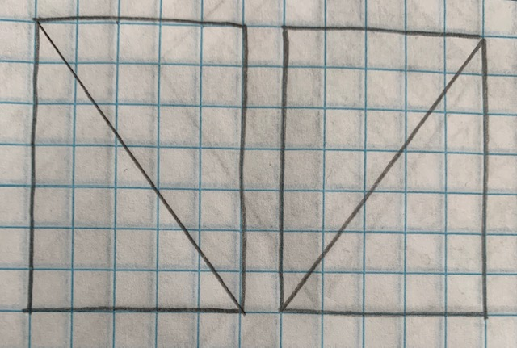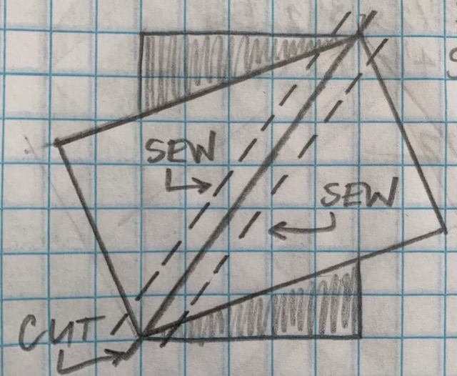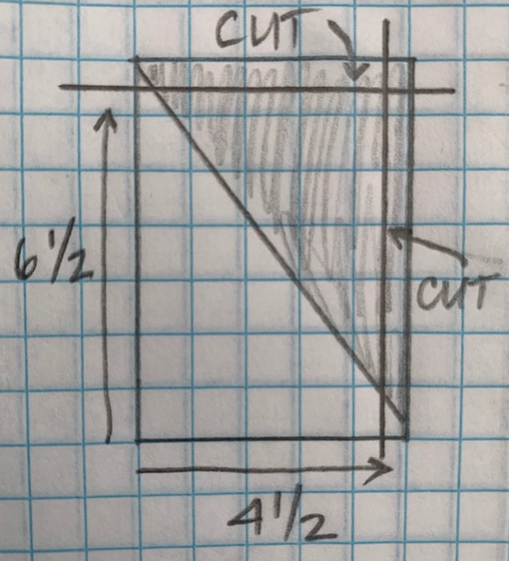
Draw a diagonal line on back of each B&W 5” x 5”, as per diagram. Place one B&W 5” x 5” on top of each BRIGHT 5” x 5”, right sides together, as per diagram. Sew ¼” on each side of drawn line, cut on drawn line, press to BRIGHT. Trim to 4 ½” x 4 ½”. Assemble two kite blocks as per diagram.

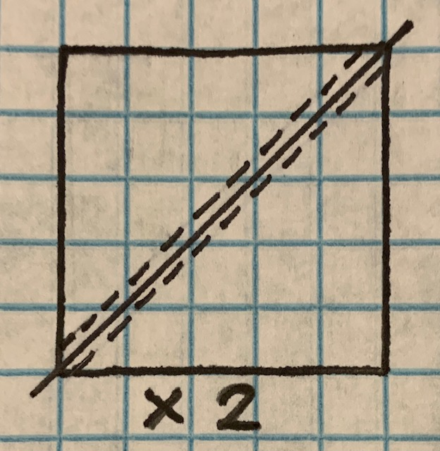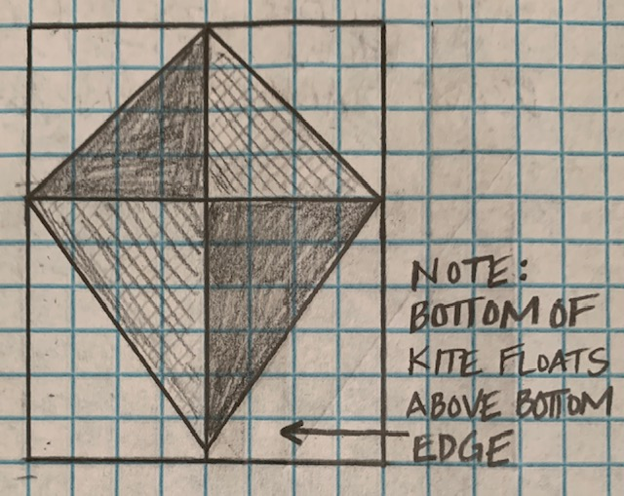

Select some of your BRIGHTEST BRIGHTS for the colors in you KITES. This pattern makes two identical KITES to fly in the breeze, each with TWO BRIGHTS. BLACK AND WHITE prints really make the BRIGHTS of the KITES stand out in the sky. How many KITES will you make?

