BLOCK of the Month: Let’s go…CAMPING in the TREES!
COLORS: GREEN Trees with TAN background
CUTTING for 9 ½” unfinished block: GREEN (1) 3 ½” x 6 ½” (1) 3 ½” x 8 (1) 3 ½” x 9 ½”
TAN (2) 3 ½” x 5” (2) 3 ½” x 4 ¼” (2) 3 ½” x 3 ½”
SEWING: Place one TAN 3 ½” x 5” across GREEN 3 ½” x 6 ½”, aligning left top corners, right sides together. See diagram for placement. Sew diagonally, from left bottom GREEN corner to right top TAN corner, trim seam to ¼”. Press to TAN to form a 3 ½” strip. Place the other TAN 3 ½” x 5”, across the TAN/GREEN 3 ½” strip you just made, aligning top right corners, right sides together. See diagram for placement. Sew diagonally, from right bottom GREEN corner to corner to left top TAN corner, trim seam to ¼”. Press toward TAN to form a 3 ½” x 9 ½” strip. Repeat above process by combining two TAN 3 ½” x 4 ¼” with GREEN 3 ½” x 8”. Then combine two TAN 3 ½” x 3 ½” with GREEN 3 ½” x 9 ½”. You have made three 3 ½” x 9 ½” strips. Sew strips together to make a tree: point on top, then middle, and wide tree base at the bottom, as per diagram.
Use one GREEN for your tree and one TAN for your background to make each block. Prints or solids are fine for both the tree and the background. When these tree blocks are joined block to block, a bonus tan tree appears upside down between the green trees, how neat is that? Let’s sew a whole forest of trees!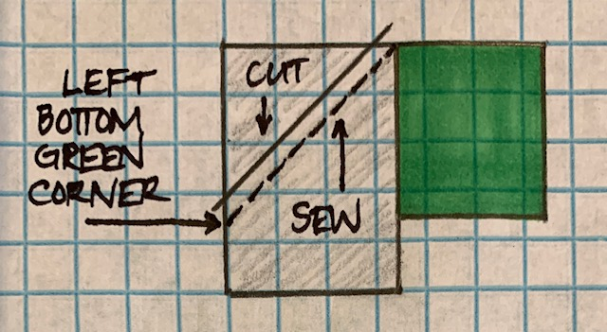 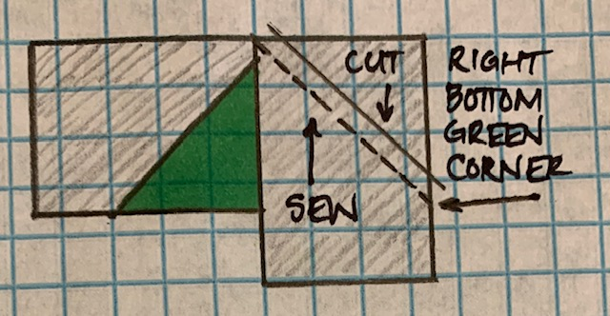 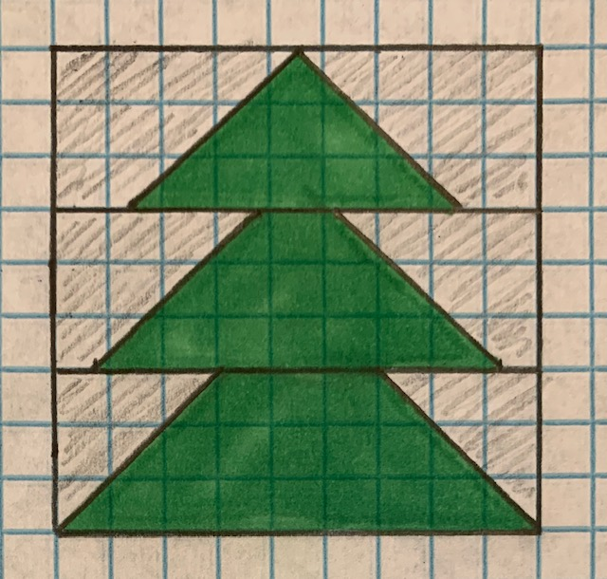
BLOCK of the Month: Let’s go…CAMPING in the TREES!
COLORS: GREEN Trees with TAN background
CUTTING for 9 ½” unfinished block: GREEN (1) 3 ½” x 6 ½” (1) 3 ½” x 8 (1) 3 ½” x 9 ½”
TAN (2) 3 ½” x 5” (2) 3 ½” x 4 ¼” (2) 3 ½” x 3 ½”
SEWING: Place one TAN 3 ½” x 5” across GREEN 3 ½” x 6 ½”, aligning left top corners, right sides together. See diagram for placement. Sew diagonally, from left bottom GREEN corner to right top TAN corner, trim seam to ¼”. Press to TAN to form a 3 ½” strip. Place the other TAN 3 ½” x 5”, across the TAN/GREEN 3 ½” strip you just made, aligning top right corners, right sides together. See diagram for placement. Sew diagonally, from right bottom GREEN corner to corner to left top TAN corner, trim seam to ¼”. Press toward TAN to form a 3 ½” x 9 ½” strip. Repeat above process by combining two TAN 3 ½” x 4 ¼” with GREEN 3 ½” x 8”. Then combine two TAN 3 ½” x 3 ½” with GREEN 3 ½” x 9 ½”. You have made three 3 ½” x 9 ½” strips. Sew strips together to make a tree: point on top, then middle, and wide tree base at the bottom, as per diagram.
Use one GREEN for your tree and one TAN for your background to make each block. Prints or solids are fine for both the tree and the background. When these tree blocks are joined block to block, a bonus tan tree appears upside down between the green trees, how neat is that? Let’s sew a whole forest of trees!

